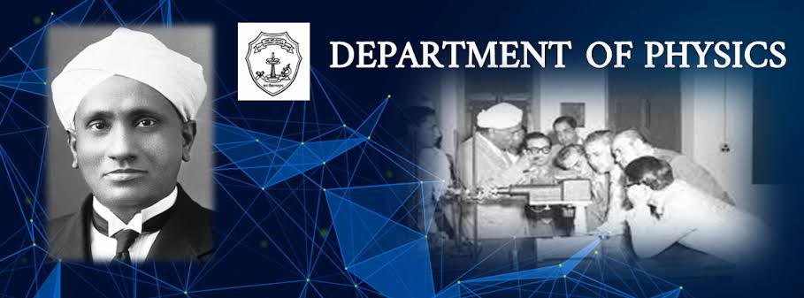

# Physics Semester Wise Syllabus

|  |
| --- |
| **Govt. Degree College, Gummalakshmipuram, ParvathipuramManyam Dist** |
| **B.Sc (M.P.Cs)- Syllabus: 2024-2025** |

|  |  |  |  |  |  |
| --- | --- | --- | --- | --- | --- |
| **S.No.** | **Title** | **Course Type** | **Year** | **Semester** | **Download** |
| 1 | Mechanics, waves and Oscillations | UG | I | I |  |
| 2 | Wave optics | UG | I | II |  |
| 3 | Heat and Thermodynamics | UG | II | III |  |
| 4 | Electricity, magnetism and electronics (PAPER-IV) | UG | II | IV |  |
| 5 | Modern physics (PAPER-V) | UG | II | IV |  |
| 6 | Low temperature physics and Refrigeration (6B) | UG | III | V |  |
| 7 | Solar energy and application (7B) | UG | III | V |  |